

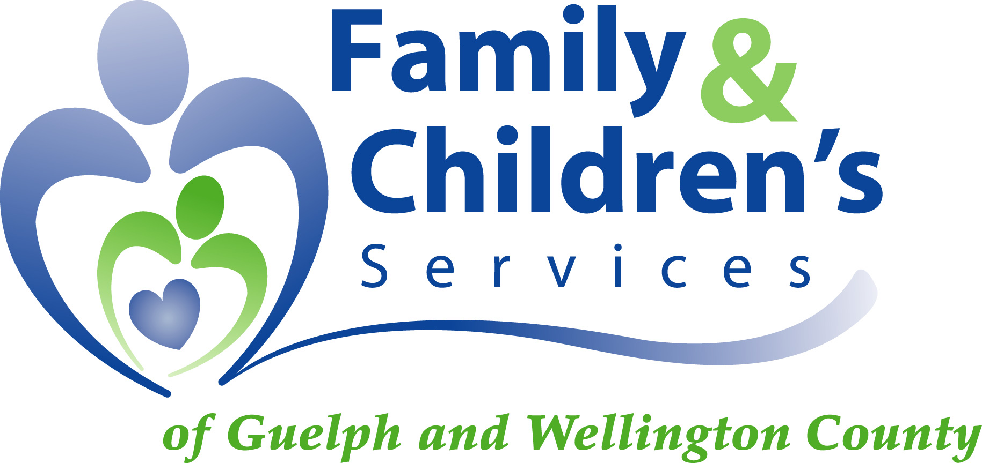
Email: info@fcsgw.org
Website: www.fcsgw.org

ANNUAL REPORT

2023-2024


Our Year in Review; Embracing Change as Possibilities
a mESSAGE FROM THE Executive Director & Board Chair

As we reflect on the past year, it’s clear that change has been a constant companion, and with it comes new possibilities for our agency. From the amazing opportunity to welcome new staff, to managing financial realities, adapting to new Regulations, and continuing to see the impacts of economic pressures on children, youth, and families. We are incredibly grateful for the leadership, support, and partnership of our community, our staff, and our Board. On behalf of the Board and Executive Team, we want to express our deep gratitude for your commitment to the work of our agency. Your collaboration and support have allowed us to continue serving children, youth, and families across our community, ensuring they have the resources and care they need to thrive.

Despite an always changing context, our dedication to our vision, mission and values remains unwavering. We have embraced change, continuing to focus on meeting the evolving needs of those we serve. This year, we embarked on a journey to develop a new strategic plan, updating our mission, vision, and values to reinforce our commitment to support our staff, to partner with our community, and to serve children, youth, and families. Community engagement has been at the heart of our work for decades. We have actively sought input from staff, community members, and partners to ensure our strategic plan adequately addresses the needs of the community.

Equity and inclusion are not just words for us; they are fundamental principles that guide our work every day. We are committed to creating an environment where everyone feels valued and respected, while we aim to deliver services that are inclusive and equitable. We have welcomed opportunities to connect as a staff team, to honor Truth and Reconciliation, Black History Month, and Pride. We also had the opportunity to increase our connections as a staff team in this post covid environment by connecting as an agency team through Townhalls, All Staff Meetings and our newly created Winter Cheer.

Partnership is a priority for us, and this past year has demonstrated the power of collaboration. Together, we have leveraged each other's strengths to better serve our community. We are continuing to invest in opportunities to connect and support one another to serve those who are most vulnerable, with compassion, and respect. We had a successful Dress Purple Day in October where we were joined by community partners to share our message of both Duty to Report and our collective Duty to Support children, youth, and families. In the Spring, we hosted our first Community, Connections and Conversations; a great opportunity to continue investing in relationships. We are grateful for the partnerships we have had for many years and the development and evolution of new partnerships that will continue to strengthen the way we deliver services across Guelph and Wellington.

Service excellence and accountability are pillars of our organization. We hold ourselves to the highest standards, continuously striving to improve and innovate to better serve our community. We aim to have programs and services that are making a positive impact on the lives of children, youth, and families. Looking to offer help earlier and in collaboration with community services remains an ongoing commitment of the agency. The ongoing development and implementation of the Village Finding initiative, and our ongoing commitment to Kinship Services are examples of this work. Additionally, we have been actively recruiting foster caregivers and volunteers to help support children, youth, and families.

We are deeply committed to the success of our youth. They are the future of our community, and we believe in providing them with the support and resources they need to thrive. In the upcoming year, we will continue to focus on supporting the success of our youth. Through mentorship, education, and opportunities for personal growth, we aim to empower our youth to reach their full potential. We will continue to implement the Ready, Set, Go! Program and the Quality Standards Framework.

We extend our heartfelt thanks to our dedicated board members for their support and commitment. Your leadership has been instrumental in the development of the Strategic Plan and in ensuring that we stay true to our mission.

To our community members, foster, kinship and adoptive caregivers, volunteers, and staff, we are immensely grateful for your selflessness and generosity. Your contributions make a real difference in the lives of children, youth, and families in our community.

As we look to the future, we are excited about the possibilities that lie ahead. With your continued support, we are confident that we can build a brighter, more equitable and inclusive future for all the children, youth, and families in our community.

Thank you for your unwavering support and dedication.






Executive Director, MSW, RSW Board Chair,
Daria Allan-Ebron Heather Broddy

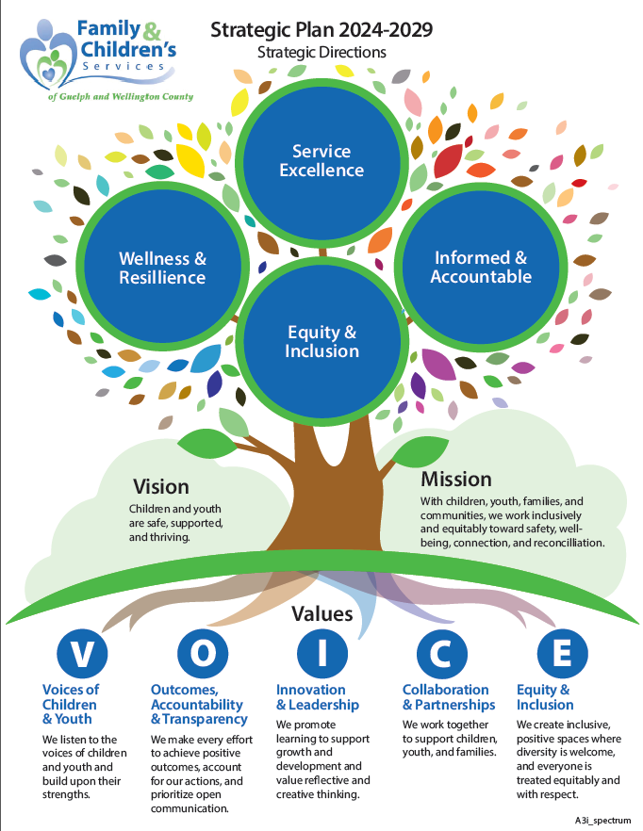
Strategic Plan 2024-2029

Family Services
Informed and Accountable
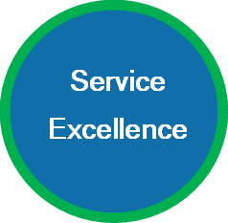
Our Service Teams are working hard to service the
increase in New Referrals.

Early Help is at the forefront of our service delivery.

Ensuring we link families to community supports and organizations if there are no child protection concerns.

Through the concerns that may arise in investigations we work to ensure the safety and wellbeing of children, youth and families and seek collaboration in ongoing services and supports to address the families ongoing needs.
~ Shea Dahuja, Director of Service, Equity, Diversity & Inclusion
~ Debbie Zen, Senior Manager of Information, Quality and Technology

Top 3 Referral Sources:
- 23% Police
- 16% Schools
- 15% Parents
Top 3 Reasons for Investigations:
- 30% Worries about physical or sexual harm
- 29% Worries about emotional harm, exposure to conflict or violence
- 21% Parent requires support to care for child
Total Protection Cases Receiving Services:
- 180 Open Cases at Start of Year
- 193 New Ongoing Cases

- 373 Total Cases Served
3,422
NEW REFERRALS
New calls received from people worried about a child

2,103
NEW NON-PROTECTION SERVICES
- Files opened for support services
- Referrals to other community organizations
- Assistance to other children’s aid societies, etc.
1,319
NEW INVESTIGATIONS
Families had worries big enough to investigate

193
NEW ONGOING SERVICES
Families needed ongoing help to address the worries

Early Help!

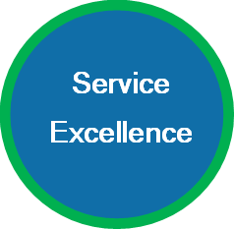
Village Finding


In the ongoing pursuit of our mission to empower families and strengthen communities, Village Finding Project has forged a pivotal partnership with the Guelph Community Health Centre. This strategic collaboration marks a significant leap forward in our efforts to create a supportive environment for children and families facing various challenges.

We are poised to appoint a dedicated coordinator who will work hand in hand with volunteers to establish a nurturing village for children and families in need. This collaborative initiative will seamlessly integrate with the esteemed Parent Outreach Worker Program, enabling us to identify and assist families whose children would benefit most from our collective support.
At Family and Children's Services of Guelph and Wellington County (FCSGW), we hold a deep appreciation for the transformative power of community partnerships. Our commitment to collaboration with organizations in the Guelph and Wellington communities reflects our belief in the importance of working together to support families comprehensively, ensuring their well-being is prioritized long before crises emerge.

In the summer of 2023, this commitment was exemplified when a mother and her two young children faced the imminent threat of deportation. In response to their plea for help, Parent Outreach Worker and their Manager reached out to FCSGW. FCSGW swiftly mobilized our network of support, pooled resources, and expertise, including tapping into the services of the Child Welfare Immigration Centre of Excellence, we were able to provide immediate emergency consultation and guide the mother to FCJ Refugee Services for specialized assistance. Our joint advocacy bore fruit – the family's deportation order was successfully halted. This outcome not only ensured the safety and unity of the family but also served as a poignant reminder of the impact that community partnerships can have in safeguarding family stability and well-being.
As we reflect on this experience, it reaffirms our belief in the power of collaboration to effect positive change. The success of this endeavor underscores the vital role that partnerships play in our mission to support families in Guelph and Wellington County. Moving forward, FCSGW remains dedicated to nurturing these alliances and leveraging our collective strengths to create a brighter future for all families in our community.
~ Shea Dahuja, Director of Service, Equity, Diversity & Inclusion

Service Data & Trends
Service Excellence
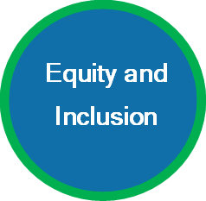

Kinship
Central to our mission is the prioritization of kinship. We are committed to fostering strong connections between children and youth and their families, communities, and cultural heritage. By integrating kinship principles organization-wide, we strive to strengthen familial bonds and cultural continuity.

When children and youth are not able to stay with their primary caregivers, our agency endeavors to place them with family members or other individuals who are known to them and their family.


Kinship providers have a biological or other significant connection to the child, youth, or family, and can include relationships such as grandparents, aunts/uncles, stepparents, family friends, neighbors, or other community members.

Kinship placements create a sense of belonging, safety and security for children and youth.

 | KINSHIP
# of Families providing Kin Placements | 77
# of Children & Youth in Kin Placements | 106

~ Shea Dahuja, Director of Service, Equity, Diversity & Inclusion
~ Debbie Zen, Senior Manager of Information, Quality and Technology

Informed and Accountable

Children and Youth in Out of Home Care
This year, FCSGW staff implemented two main
Ministry initiatives in 2023:
- The Ready, Set, Go! Program, in April 2023,

designed to improve outcomes for youth by extending agency support until their 23rd birthday and enhancing financial provisions for youth leaving care.

- The Quality Standards Framework (QSF) in July 2023, aimed at improving the quality of care, everyday experiences, and outcomes for children and young people receiving licensed residential services in the province.

As of March 31, 2024, we had 133 children and youth in out of home care.

This year we had 57 children and youth ending service and their out of home placements.



The Top 3 Reasons that out of home placements ended:
- 12% Child & Youth returned home
- 19% Adoption completed
- 37% Youth over 18 years old, left care voluntarily

Service Impact


Strength & Resilience
The past year revealed the strength and resilience of our children and youth, staff, foster caregivers, and community partners. Our children and youth in care population continues to trend downwards, as our service teams worked diligently to keep children and youth safe in their homes and support permanency efforts.

We have had many moments of joy and happiness, celebrating with the families we work with. One of our Family Services Teams supported a youth who immigrated to Canada to reunite with their father and stepmother. The family had high hopes, dreams, and expectations for their new life together. However, they soon faced conflicts and challenges due to differing values. These differences led to the youth needing to stay with a family friend for a short period of time.

To find a resolution, the family and their community supports, including the youth’s mother who remained in their country of origin, came together to plan for the youth.

The youth expressed a heartfelt wish to return to their mother’s care. After exploring various options and consulting with the Child Welfare Immigration Centre of Excellence (CWICE), health partners, and school board, the family decided to honor the youth’s wishes and facilitate their return to live with their mother in their country of origin.

Foster Cargivers
This year continued to present challenges related to foster placement shortages, both locally and provincially. We remain committed to addressing these issues, as they have significantly impacted our ability to keep children and youth within their communities, where they can maintain essential connections and access local resources. Finding appropriate placements for children and youth with complex needs is particularly challenging due to their need for specialized care and support. There is a need for foster caregivers from diverse backgrounds, including Indigenous, Black, 2SLGBTQIA+, and individuals who can care for children and youth with complex needs, sibling groups, adolescent youth, and infants.

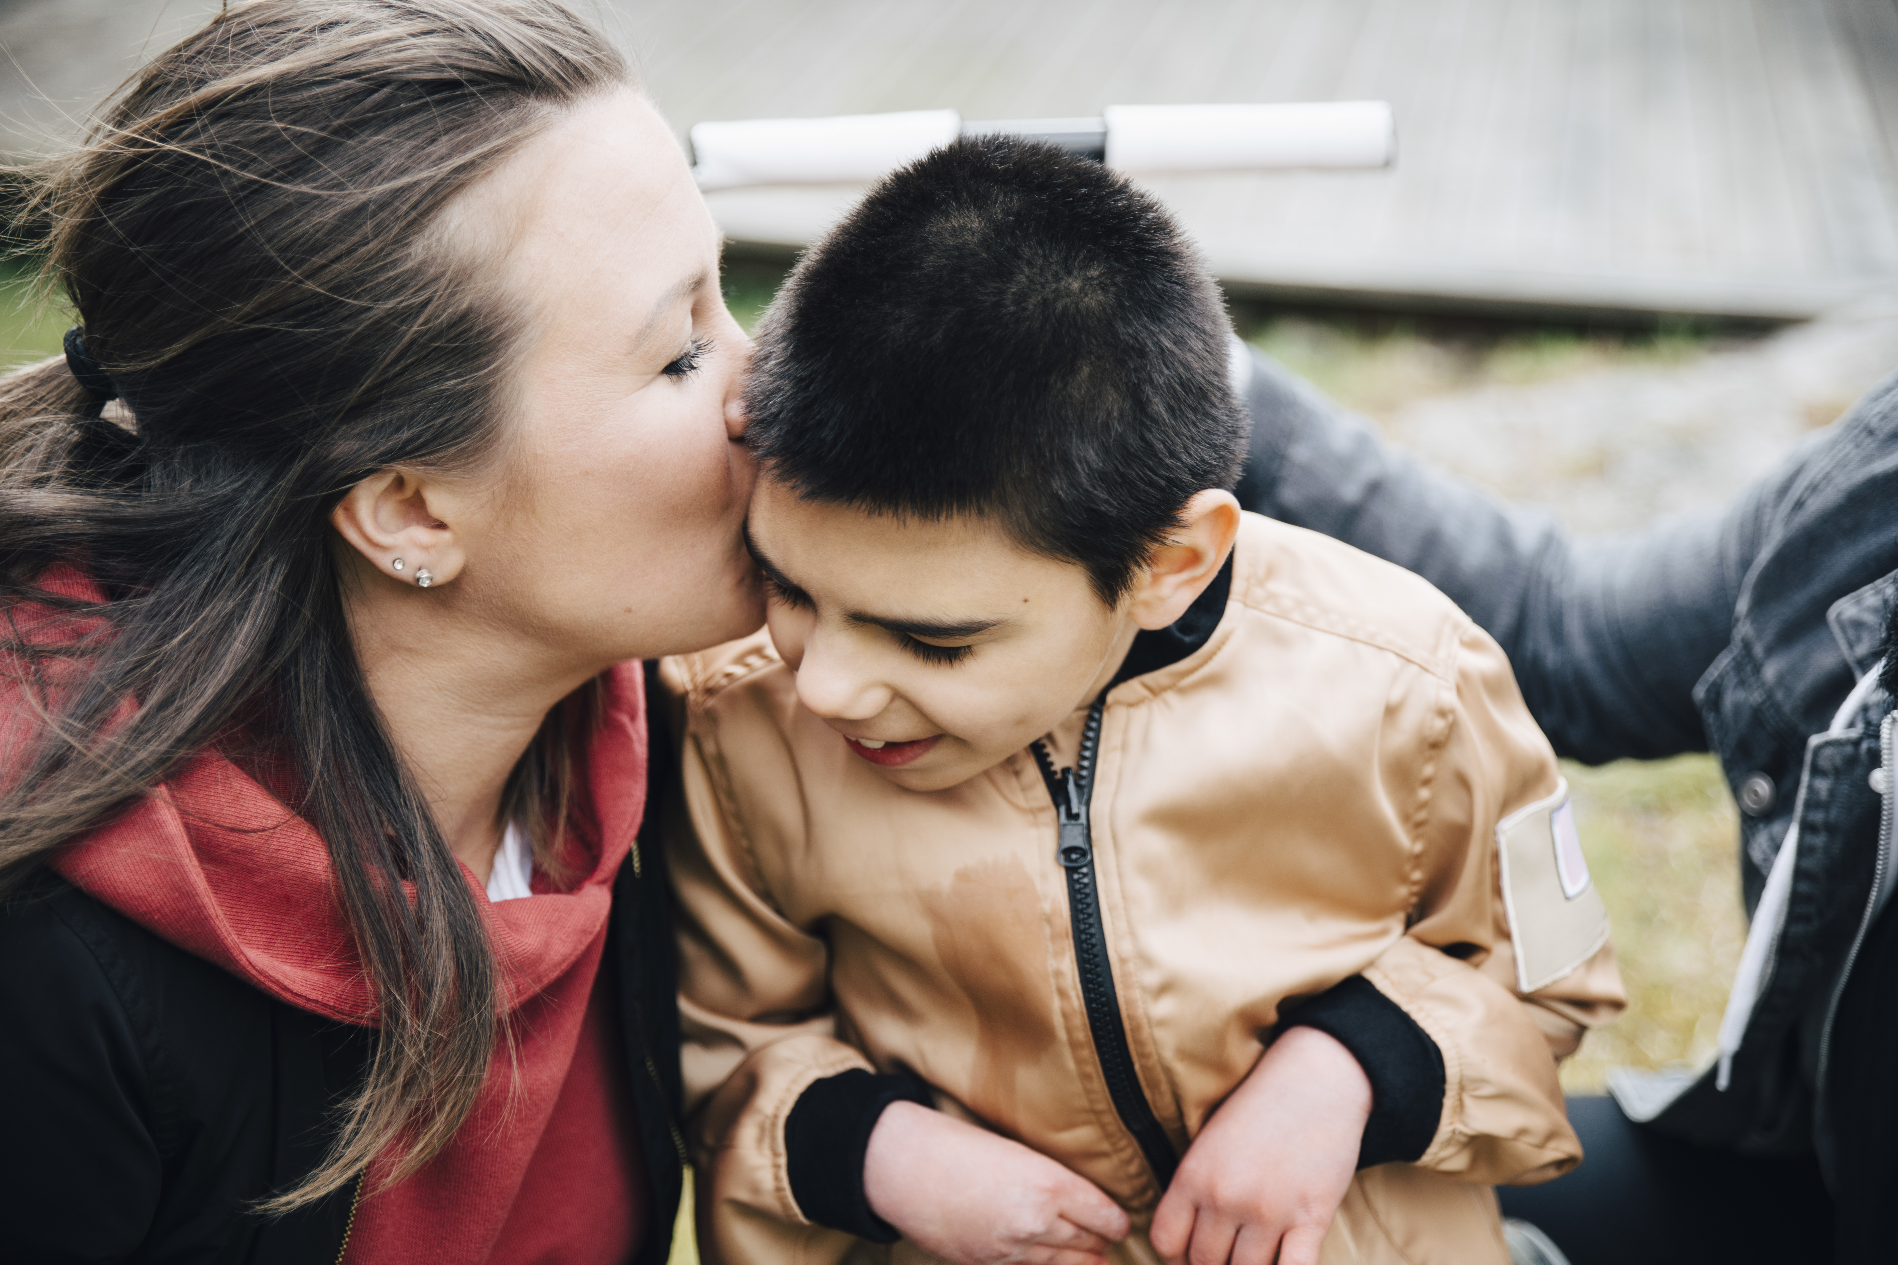
In response to the placement challenges, foster caregiver recruitment is a key service priority. Our foster caregivers are provided with training aligned with the new Ministry requirements under Quality Standards Framework (QSF), such as Indigenous learning, trauma, equity, and first-aid. This year, we also launched a foster caregiver Coffee Time, where caregivers and staff can come together to chat about shared experiences, problem-solve, and strengthen connections.

Additionally, children and youth face unique challenges that require a stable and understanding environment to help them thrive. Following a social media campaign for foster caregivers to care for infants, we received an overwhelming response from the community expressing interest in becoming foster caregivers. This response is encouraging, and we look forward to welcoming new foster caregivers to support our efforts in meeting the diverse identity, emotional, and behavioral needs of children and youth requiring out-of-home placements.

Looking Ahead: Youth Success Strategy
We have a lot to look forward to in the upcoming year and are excited to embark on the development of the agency’s Youth Success Strategy, which will emphasize readiness supports and services for youth in care and those transitioning to adulthood. Youth transitioning from the child welfare system often face outcome disparities compared to the general youth population, due to a lack of housing stability and supportive relationships, which increases their risk of experiencing homelessness, mental health issues, unemployment, educational struggles, and involvement in the justice system.


The Youth Success Strategy, in partnership with youth and community allies, aims to address outcome disparities, and build youth resilience in the areas of employment, education, housing, building connections, financial literacy, health, and wellness.

The voices and experiences of youth, principles of equity, and the Ready, Set, Go! program will anchor our Youth Success Strategy, enhancing and reimagining services and supports for youth in Guelph and Wellington County.
~ Danielle Mitchell, Director of Service

Commitment to Equity & Partnerships
Service Excellence

At our organization, we are passionately committed to honoring and elevating the principles of equity at all levels to address disproportionalities and disparities. This vital mission requires a shared responsibility to center equity in our governance, leadership, policies, procedures, organizational culture, services, and community partnerships. Through strategic partnerships and aligned efforts, we are working to ensure equitable outcomes. There are several aspects of this alliance that merit celebration:

- Indigenous Consultation Policy: We have initiated the development of a comprehensive policy outlining the necessity for consultation with Indigenous consultants and/or communities when working with Indigenous children and youth.
- Emphasis on Kinship and Family Connectivity: Central to our mission is the prioritization of kinship. We are committed to fostering strong connections between children and youth and their families, communities, and cultural heritage. By integrating kinship principles organization-wide, we strive to strengthen familial bonds and cultural continuity
- Customized Service Delivery: Our service model is tailored to reflect the principles outlined in the sector's nine Indigenous commitments, the One Vision One Voice (OVOV) Race Equity Practices, and the 2SLGBTQ+ Provincial Report. This personalized approach ensures that our services are culturally responsive and inclusive of diverse identities.
- Bias Mitigation through Case Conferencing: Our internal multi-disciplinary teams, including the legal department and the Equity, Diversity, and Inclusion Manager, engage in regular case conferencing sessions to analyze and challenge biases within our practices. These sessions foster critical reflection and promote fairness in decision-making.
- Employee Resource Groups and Committees: We have established a range of Employee Resource Groups (ERGs) and Committees dedicated to fostering inclusivity and addressing systemic inequities. Some of these groups are: Confronting Anti-Black Racism, Indigenous Learning Circle, 2SLGBTQ+ Committee (new name in the works), Cultural Consultation Table and Equity Council.

Collaboration within and beyond our organization enables us to leverage diverse perspectives, expertise, and resources to tackle complex challenges related to equity and inclusion and acts as fundamental principles, guiding our actions and our service to the communities in Guelph & Wellington County.

~ Arnab Quadry, Senior Legal Counsel
~ Shea Dahuja, Director of Service, Equity, Diversity & Inclusion


2024 Award of Merit Recipients

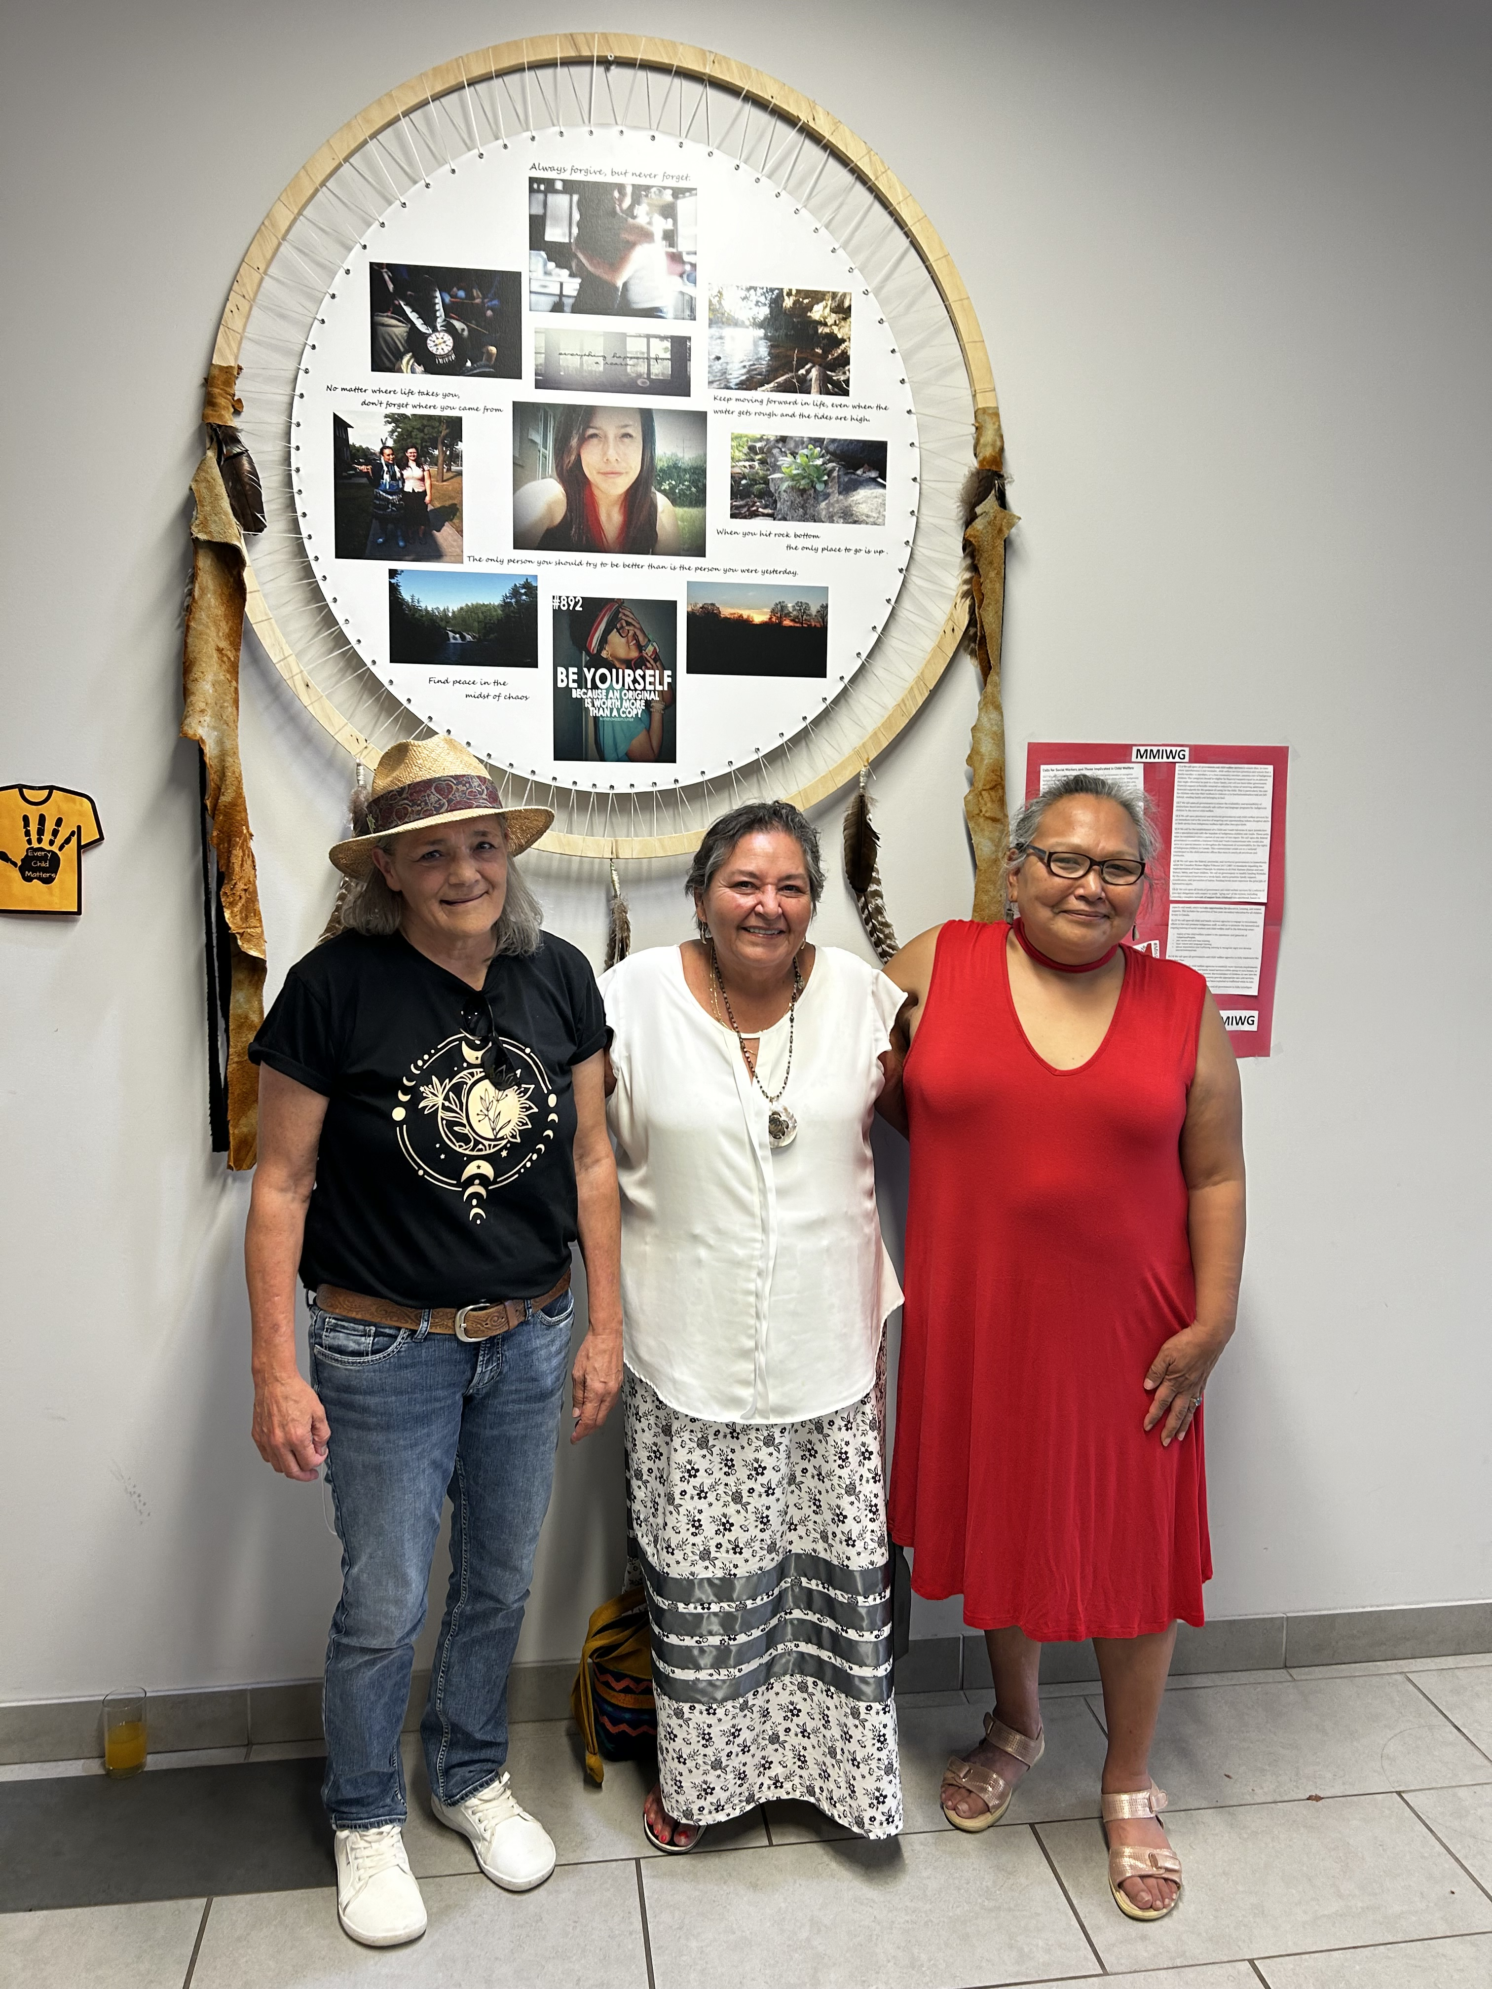
Wendy Sero Stewart, Donna Dubie and Tauni Sheldon are Indigenous leaders recognized by the Board of Directors of Family & Children’s Services Guelph-Wellington, with the Award of Merit, for their steadfast commitment to Indigenous communities.

The invaluable contributions of these Indigenous leaders and unwavering dedication to their communities serves as an inspiration to us all. Their tireless advocacy for the welfare of Indigenous children, youth and families leaves a legacy, illuminating a path towards a brighter future.

Through their leadership they not only provide guidance but also foster resilience and hope within their communities. We have a deep appreciation for the genuine and profound impact they continue to make, shaping a world where every child’s rights and well-being are upheld, and where the child welfare system is accountable.

From Left to Right: Wendy Stewart, Donna Dubie, Tauni Sheldon


2024 Award of Merit Recipients

Wendy is the founder of Tall Tree Consulting/Tall Tree Peace Building Circles, a First Nations provider that works primarily with Indigenous families who are involved with the child welfare system. Wendy has been providing consultations and Original/Indigenous Dispute Resolution services to the Guelph and Wellington community for 18 years. Wendy has also offered training to the agency and has always been committed to changing outcomes for Indigenous families, children, and youth.

Donna Dubie is the Founder and the Executive Director for The Healing of the Seven Generations. The Healing of the Seven Generations has been in the community since 2001. Donna has a long-standing relationship with FCSGW and while located in Waterloo Region, services are available to children, youth, and families in Guelph-Wellington. Healing of the Seven Generations offers twenty specific programs for First Nations Métis and Inuit (FNMI) peoples. Some include youth support, court support, one to one counselling, life skills, a location for access visits, advocacy, and cultural programs.

Tauni Sheldon is a Cultural Advisor who works with Tungasuvvingat Inuit (TI). TI is an Inuit-specific registered not-for-profit Ontario service provider offering social support, cultural activities, employment and education assistance, youth programs, counselling, crisis intervention and more. Tauni has also provided Inuit training for FCSGW and recently introduced us to the Kamatsiarniq Program and colleagues from TI.

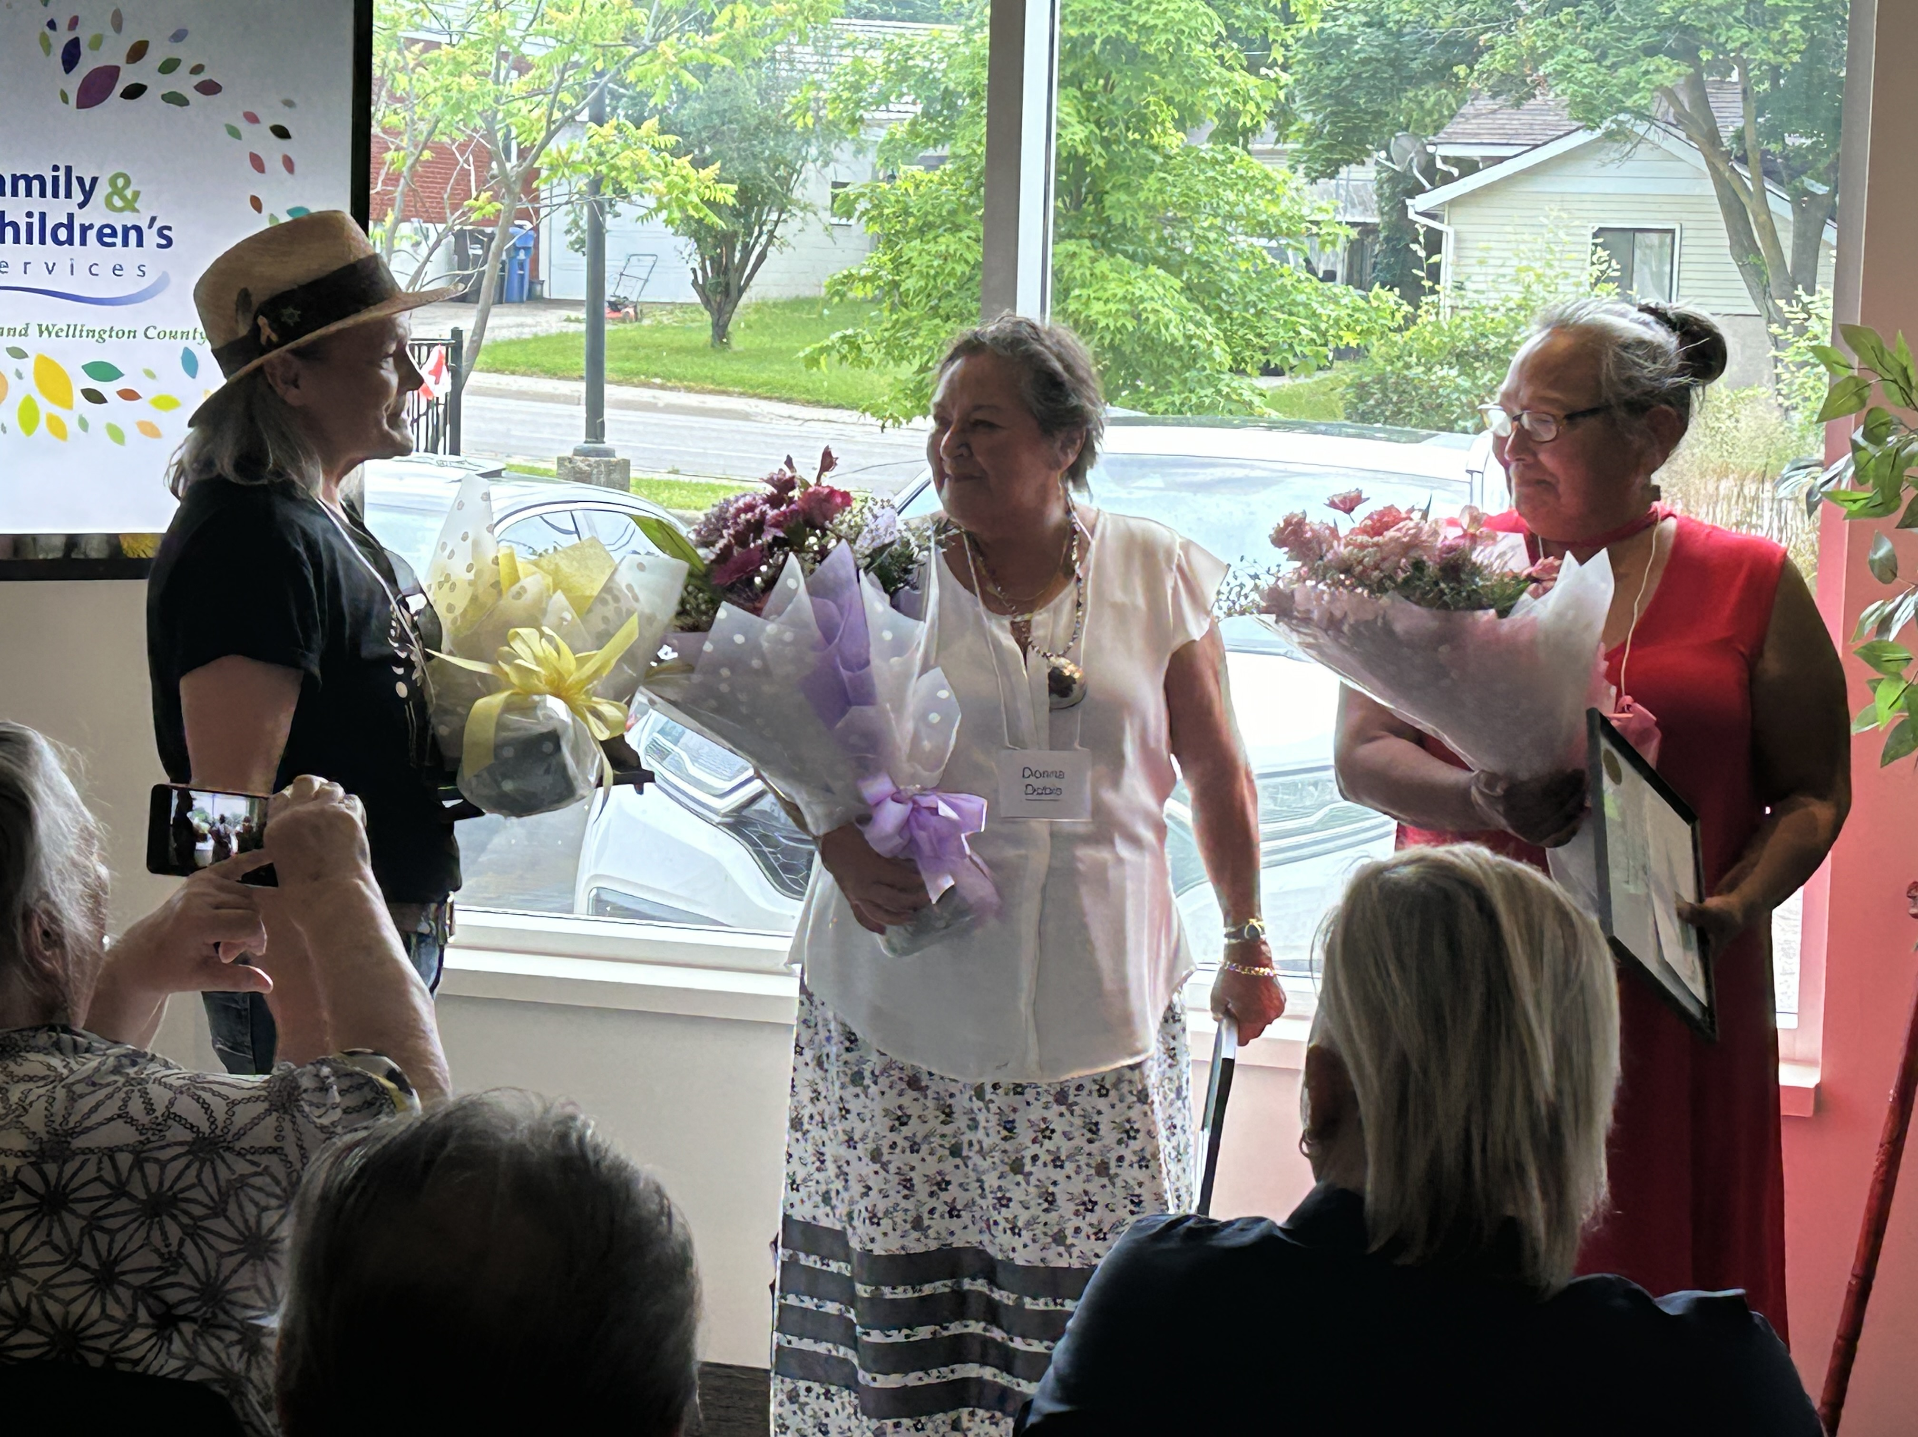
We are incredibly grateful for the opportunity to collaborate and partner with Wendy, Donna and Tauni; working together to disrupt and change the legacy of child welfare with Indigenous communities. FCSGW is committed to continuing to strengthen our knowledge of Indigenous, Inuit and Metis history and to the ongoing work to change the outcomes for Indigenous children, youth, and families.

From Left to Right: Wendy Stewart, Donna Dubie, Tauni Sheldon

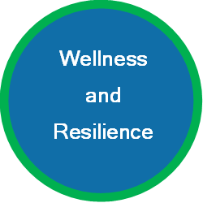
Employee engagement and organizational wellness

Systems Updates
The Human Resources (HR) team completed the design and implementation of a new Payroll and Time & Attendance system with AVANTI. The HR team is now working on the HRIS (Human Resources Information System) phase of implementation. This will bring all staff information into one main system, creating efficiencies as well as better self-serve options for staff.

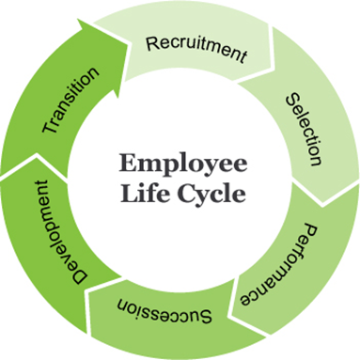
HR Focus
The HR team began to refocus on core HR values and deliverables to ensure we are providing support to all staff at the agency that aligns with our strategic plan, operational plan, and staff feedback. We know there is parallel impact to the clients we are here to serve, and the support HR provides to the staff at FCSGW. The HR team has begun to focus on the Employee Life Cycle, including an enhanced Equity Diversity Inclusion lens at all stages.

A fresh approach to Recruitment and Selection (including onboarding) efforts have resulted in increased diversity on the front line and at all levels of leadership, adding lived experience to provide even better service to our clients. Achieving an 86% completion rate of annual Performance Appraisals was an important step to move Development and Succession planning forward.

Wellness
Staff wellness remained and continues to remain a high priority at the agency and within the HR team. The Employee Wellness Program is based on feedback from all staff through a variety of feedback mechanisms; the Annual Employee Engagement Survey, Wellness Survey, a Wellness Working Group, and regular feedback from staff.

The program is based on 4 key themes:
- Mental Health and Wellness in the Workplace
- Personal Wellness
- Healthy Living
- Critical Incidents and Wellness
Sharing information, tools, resources, holding events/activities, gathering feedback, and engaging in learning opportunities have supported wellness initiatives.
~ Bethany Comeau, Director of Employee Engagement and Organizational Wellness

Volunteer Impact

The volunteers at Family and Children’s Services of Guelph and Wellington County make “Every Moment Matter” through their commitment to being part of our caring network. They can spend time with a child, youth or family in ways that make a positive and lasting impact.

On National Volunteer Week (April 14-20) we recognize and celebrate our volunteers for their contribution to strengthening connection to community and the lasting impact they make.

338 Connections for children and youth
28 Mentors, Youth Mentors & Homework Helpers made 338 connections to community for 35 Children & Youth through community-based activities or opportunities. Enjoying time together at libraries, recreation centers, job interview preparation skills, sharing a meal, playing games, making crafts, baking & cooking together.
68 Friendly visits for parents or caregivers
6 Family Support Volunteers provided 68 friendly visits and connection to community resources to 8 different families. Helping to reduce isolation and building relationships with the community.
61,500 KM Driven!
12 Volunteer Drivers provided transportation for families to connect with each other, resources, and services. This includes Family or Kin Visits, extracurricular programs, and medical appointments.

~ Karan Mann, Manager of Equity, Diversity & Inclusion
~ Hannah Senitt, Coordinator of Volunteer Services

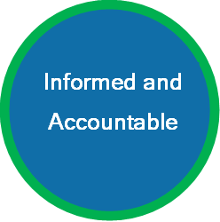
Children’s First Fund


It was another great year for the Children First Fund. We owe many thanks to the generosity of our donors, the commitment of our community partners, and the dedication of our network of staff, volunteers, committee members, and Board of Directors. The combined efforts to maximize impact carry us into our next fiscal year as we explore more opportunities to provide support.

The Children First Fund continues to fill critical funding gaps, thanks to our incredible supporters, through three areas of impact: Building Opportunities for Youth Success, Meeting Urgent Needs, and Enriching Lives. Each area of impact provides unique and individualized support to vulnerable children, youth, and families involved with FCSGW.

“As we move into our next fiscal year, guided by our new Strategic Plan and feedback from our clients, donors, committees, and community partners, we remain steadfast in our goal to ensure children and youth are safe, supported, and thriving.” - Kristen Granger, Fund Development & Communications Manager

Some examples of impact in each area include:
- The McColl-Early Foundation donated $9,380. Assisting 7 youth transitioning to independent living.
- Westwood & Starwood Dental provided 25 youth enjoyed a warm holiday meal and 45 youth who live independently received a special gift!
- Laura Greenway shopped and filled the pantry with essentials to help meet the needs of youth formerly in care. 30 youth accessed support available through the youth pantry from December 2023 to January 2024.
- Thanks to the Guelph Lions Club and assistance of Danby Appliances, 15 have been distributed through our one-of-a-kind Car Seat Program.

How You Can Help!
- You can join the incredible network of Children First Fund supporters today by donating to the area of impact that most resonates with you or have an ongoing impact by becoming a monthly donor.
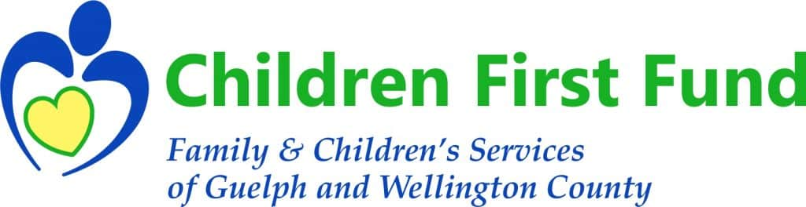

~ Kristen Granger, Fund Development and Communications Manager

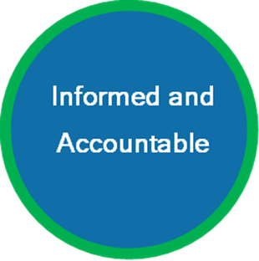
CHILD WELFARE OPERATIONs 2023-24 Results
Audited financial statements available upon request.
chnology Tips

REVENUE

Child Welfare funding | $ 21,719,134
Other non-recurring revenue | 803,433
REVENUE TOTAL | $22,522,567
EXPENDITURES
Staffing | $ 14,466,505
Boarding rates | 4,167,448
Infrastructure & administration | 1,988,482
Client support | 843,650
Adoptions | 795,915
Travel | 260,567
EXPENDITURES TOTAL | $ 22,522,567
NET SURPLUS (DEFICIT) | Nil
~ Stéphane Chalifour, Director of Finance

Board of Directors 2023-2024

Chair:
Heather Broddy
Vice-Chair:
Al Potma
Secretary Treasurer:
Shaun Valerorite
Directors:
Animesh Vadaparti
Chase Collver
Christine Sowden
Conor Russell
Nicole Kucherenko
Sharon Mayne
Shikha Jain

Head Office
275 Eramosa Road, Box 1088, Guelph, ON N1H 6N3

Shelldale Centre
20 Shelldale Crescent, Box 1088, Guelph, ON N1H 6N3

County Office
6484 Wellington Road 7, Elora, ON N0B 1S0

Email: www.fcsgw.org

Phone: 1-519-824-2410

Toll Free: 1-800-265-8300

